Contents

1. Introduction
   1. Project definition
   2. Need of the project
   3. Problem statement
   4. Scope of new system
   5. Development environment
   6. Tools and techniques used
2. Requirement specification

2.1. Feasibility study

2.2. Modules of the system

2.3. Process model

2.4. Use cases

1. System design
   1. System flow chart
   2. Dataflow diagram
   3. ER diagram
   4. Data dictionary
   5. Input design layout
   6. Output design layout
2. Limitations and failure
3. Bibliography/references
   1. Introduction
   2. Project Definition

Library management system, a desktop application system to perform various library related activities effectively and efficiently.

* 1. Project Description:

This proposed system provides access to library members and stakeholders to perform various tasks. Librarian can perform tasks like issue, return, add members, add/delete/modify book records etc. Members will be able to search and request resources from library system.

* 1. Existing/Legacy System or Work Environment:

There is no such computerised system available in the library. Librarian and Library staffs are handling tasks manually.

* 1. Problem Statements:

Followings are the disadvantages of current system:

* Requires a lot of records to manage whole library.
* Time consuming.
* Inefficient searching.
* Inefficient in issue, return and add books.
* Too much workload on the staffs.
* Data redundancy
  1. Need of new system

The new system is required for the following purposes:

* To manage book and member record easily and effectively.
* To save time and resources.
  1. Scope of new system:
* To make the existing system more efficient.
* To provide a user friendly environment where user can be serviced better.
* Make functioning of library faster.
* Provide a system where the library staff can catch defaulters and not let them escape.
* To minimize the loss done to books.
  1. Development environment (Tools & Technology used):
  + **Hardware configuration:**
    - * Processor: Intel(r) Colcon, 1.70 GHz
      * RAM: 4.00GB
      * System type: 64 bit operating system, windows 10
  + **Software:**
    - * Language: c++
      * Operating system: Windows 10
      * Editor: Code Blocks

1. Requirement Specification:

2.1 Feasibility study:

Technical feasibility

* In this system we have used c++ language which is supported by almost all computers. So this project is technically feasible.

Operational feasibility

* The system will be easy to use as user interface is GUI based.
* The system is easy to use so no any special skills will be required to use the system, user only require the basic knowledge of English and computer.
* New user will find it easy to use

Economic feasibility

* The procedure is to determine the benefit and savings that are expected from the project and compare them with the cost.
* In this system we have used free and open source software like code blocks, pencil and language like c++.
* So the project is economically feasible

**2.2** Modules of the system:

* Issue book:
  + - * Here you only need to insert student and book id number.
  + Return book:
    - * Here you only need insert student’s id number.
  + Add book:
    - * Here you only need to insert book information like book name, book id, book price and rake no.
  + Add member:
    - * Here you only need to insert member information like member name, member id member department and member type.
  + Delete book:
    - * Here you only required to insert book id and that book will be permanently deleted from database.
  + Delete member:
    - * Here you only required to insert member id and that member will be permanently deleted from database.
  + Display book:
    - * Only by inserting book id you can see all books currently present in the library
* Display member:
  + - * Only by inserting member id you can see all members registered in your system.
* Update book:
  + - * Here only by entering book id you can update the whole record of that particular book.
* Update member:
  + - * Here only by entering member id you can update the whole record of that particular member.

2.4 Process Model / Development Model:

* For process and development of this proposed system, we have identified classical SDLC model.

3. System design

3.1 System flow chart:

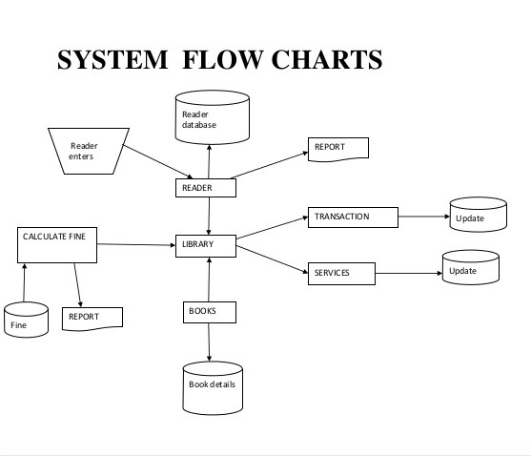

* 1. Dataflow diagram:

**0 TH LEVEL DFD**

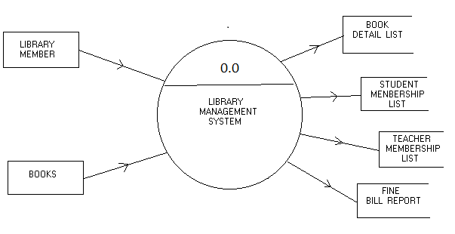

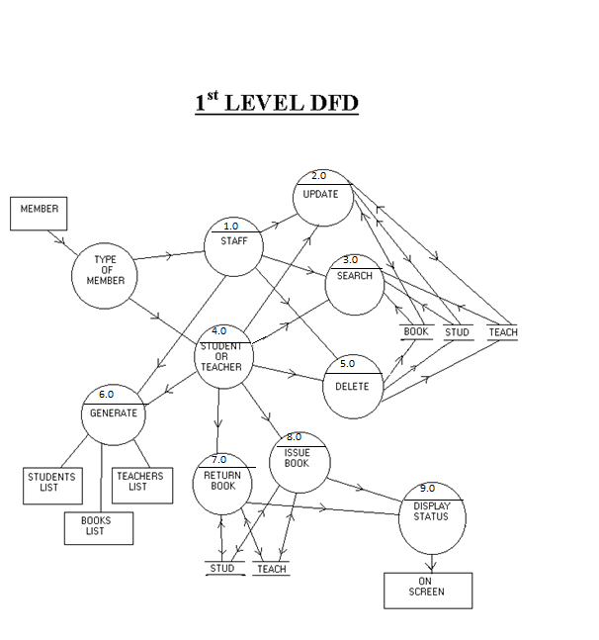

* 1. ER diagram:

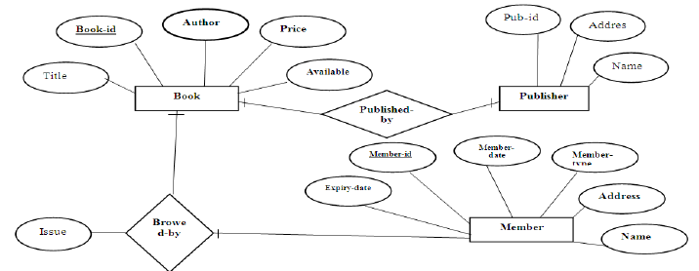

* 1. Data dictionary

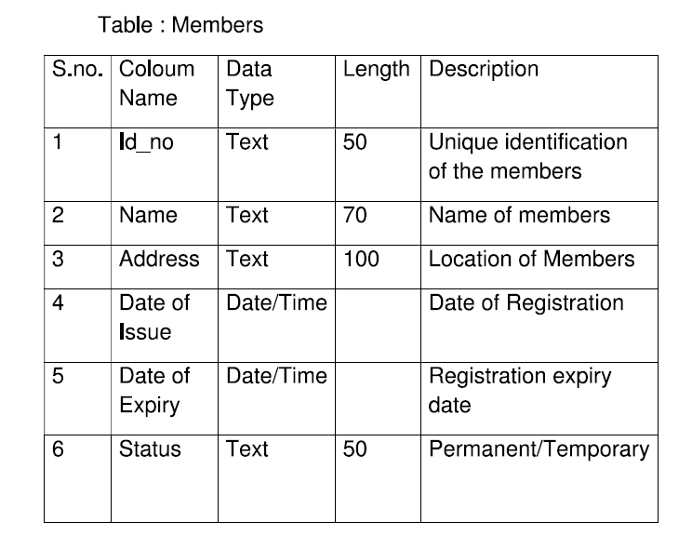

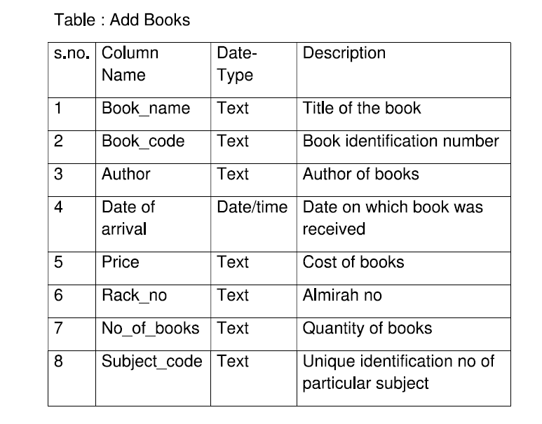

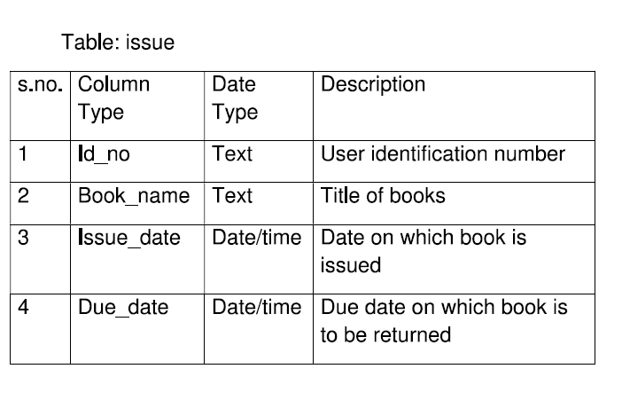

1. Limitations and Future Scope

* It can be upgraded with Biomatrix, barcode or punch card techniques.
* Members can be issue e-book s.

1. Bibliography/References
   1. Books

* Object Oriented Programming with c++,E Balaguruswami, Mc Grew Hill 6th edition.

5.2 Web Links:

* <https://sites.google.com/a/paruluniversity.ac.in/pu-sem-2-ssad/home/academic-docs>
* [www.scribd.com](http://www.scribd.com)
* [www.apache.org](http://www.apache.org)
* [www.slideshare.net](http://www.slideshare.net)